To setup environment for running app, follow below steps:

1. Install node in your pc.
2. Go to project folder and open cmd.

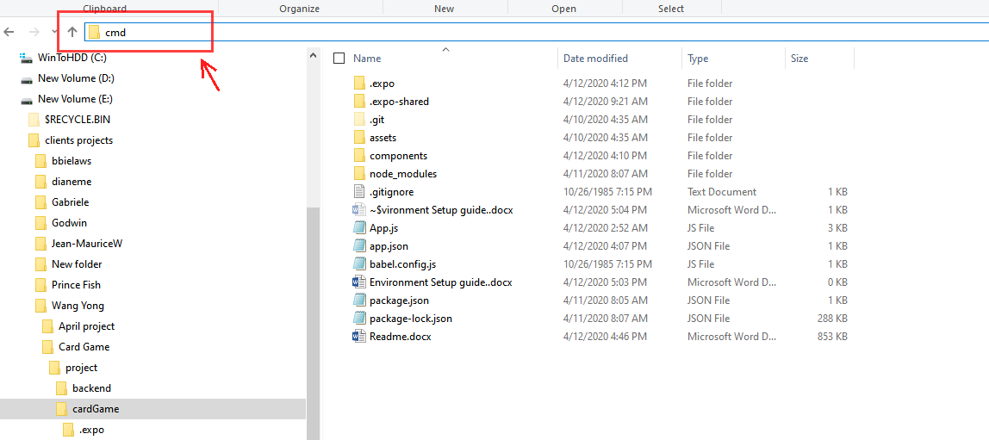

1. Run “npm install” command.

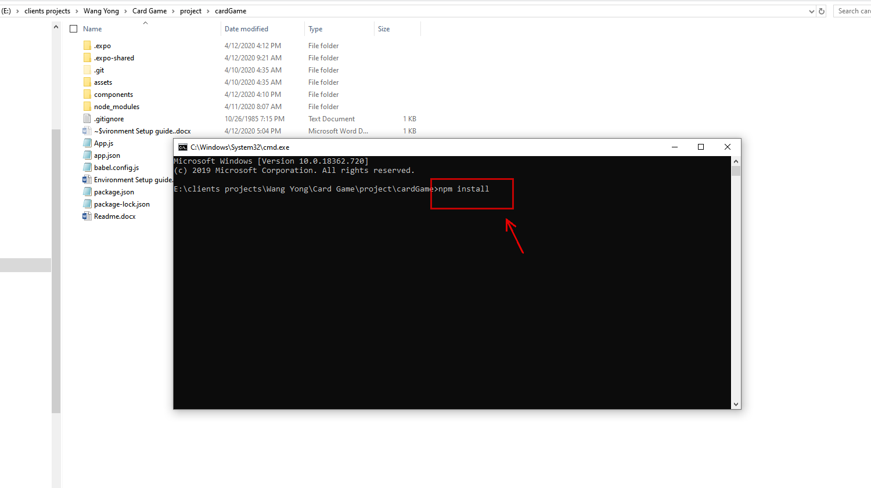

1. After install “node_modules” and run “npm start”

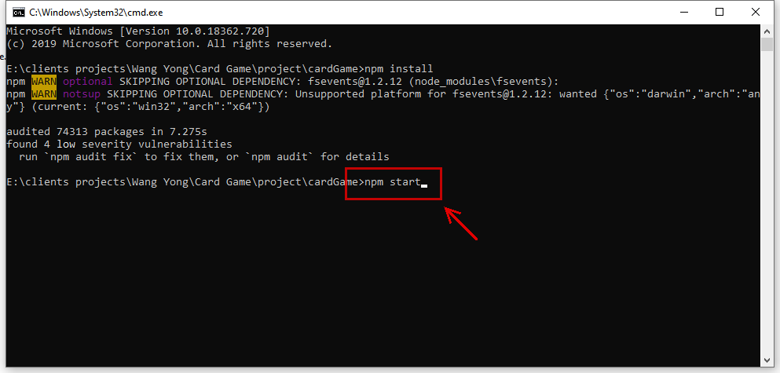

1. Then, web browser will open and show barcode.

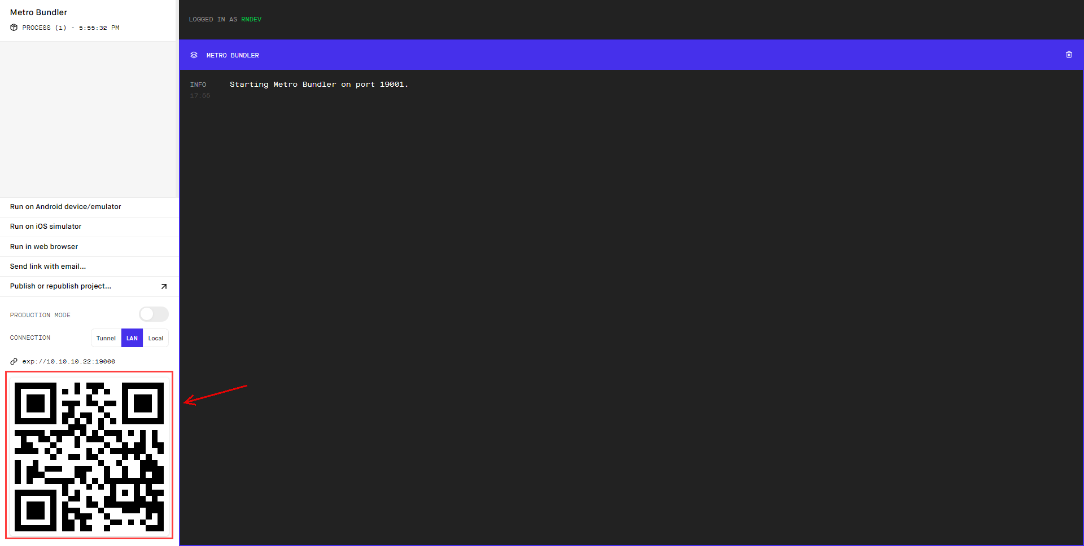

1. Go to backend folder and run cmd as above. And run “nodemon index.js”

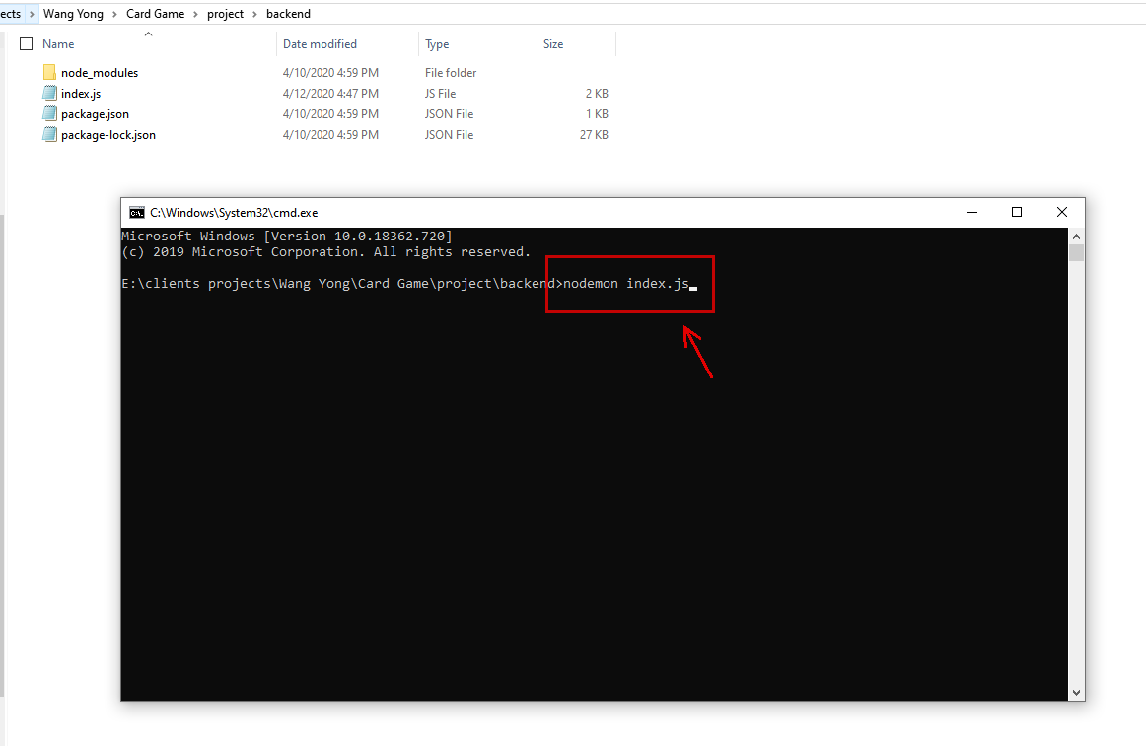

1. Then, install Expo app in your device (iphone & android)
2. Run expo and click here:

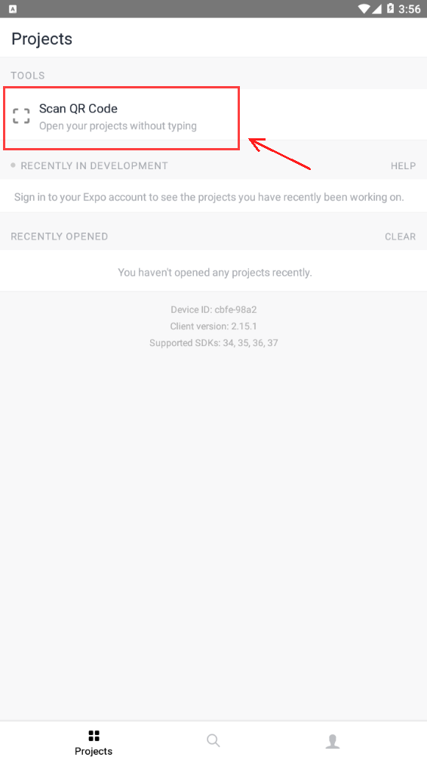

1. If you scan barcode, then expo will show app.
2. That’s all. Now you can start game.